Course Three

Go Beyond the Numbers: Translate Data into Insights


Instructions
Use this PACE strategy document to record decisions and reflections as you work through this end-of-course project. You can use this document as a guide to consider your responses and reflections at different stages of the data analytical process. Additionally, the PACE strategy documents can be used as a resource when working on future projects.

Course Project Recap
Regardless of which track you have chosen to complete, your goals for this project are:
- Complete the questions in the Course 3 PACE strategy document
- Answer the questions in the Jupyter notebook project file
- Clean your data, perform exploratory data analysis (EDA)
- Create data visualizations
- Create an executive summary to share your results

Relevant Interview Questions
Completing the end-of-course project will help you respond to these types of questions that are often asked during the interview process:
- How would you explain the difference between qualitative and quantitative data sources?
- Describe the difference between structured and unstructured data.
- Why is it important to do exploratory data analysis?
- How would you perform EDA on a given dataset?
- How do you create or alter a visualization based on different audiences?
- How do you avoid bias and ensure accessibility in a data visualization?
- How does data visualization inform your EDA?
Reference Guide
This project has six tasks; the visual below identifies how the stages of PACE are incorporated across those tasks.
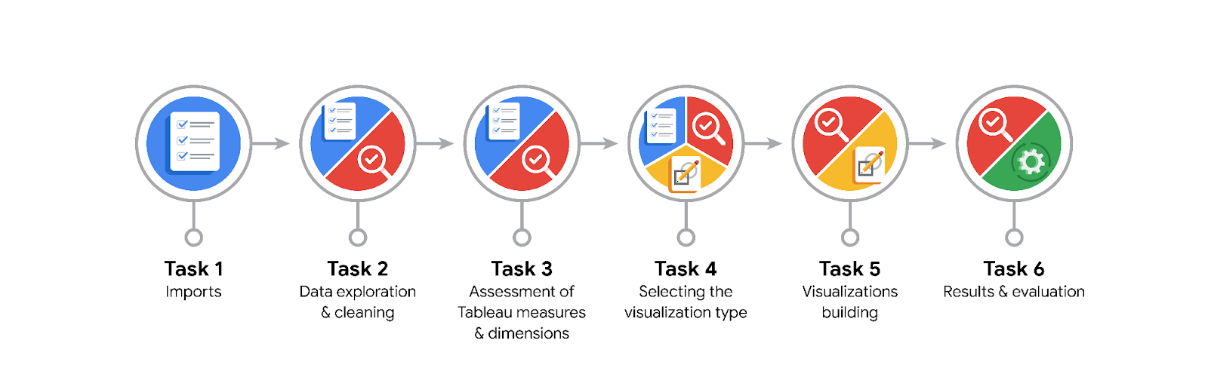
Data Project Questions & Considerations

PACE: Plan Stage
- What are the data columns and variables and which ones are most relevant to your deliverable?
The dataset contains information about New York City yellow taxi trips in 2017.
The dataset contains 18 columns describing 2017 NYC Yellow Taxi trips, including vendor ID, pickup/drop-off datetime, passenger count, trip distance, payment type, and several fare-related fields.
The most relevant variables for analysis are trip_distance, fare_amount, tip_amount, total_amount, and the pickup/drop-off timestamps.
A new variable, trip_duration_minutes, was created to calculate ride duration and support time-based analysis.

- What units are your variables in?
trip_distance: miles
fare_amount, tip_amount, total_amount: U.S. dollars (USD)
pickup/drop-off datetime: timestamp (YYYY-MM-DD HH:MM:SS)
passenger_count, RatecodeID, PULocationID, DOLocationID: numeric or categorical identifiers without measurement units.

- What are your initial presumptions about the data that can inform your EDA, knowing you will need to confirm or deny with your future findings?
Most taxi rides are expected to be short (1–3 miles) with low fares and small tips.
Distributions of distance and fares will likely be right-skewed due to a few long or expensive trips.
Some records may include zero-distance rides or negative fares, indicating data-entry errors.
These assumptions will be tested and validated during exploratory analysis.

- Is there any missing or incomplete data?
There are no missing values in the dataset according to the info() function.
However, several negative values appear in fare-related fields (fare_amount, extra, mta_tax, total_amount).
These represent data entry errors and should be removed or corrected before analysis.

- Are all pieces of this dataset in the same format?
Not initially.
The pickup and drop-off datetime columns were stored as text and had to be converted to datetime for duration and trend analysis.
After conversion, all variables were in consistent and appropriate formats for analysis and visualization.

- Which EDA practices will be required to begin this project?
TUse info(), describe(), and head() to inspect structure and summary statistics.
Clean invalid or negative values.
Create new features like trip_duration_minutes, month, and day.
Detect outliers using boxplots and histograms.
Group data by time and passenger count for pattern detection.
Visualize key metrics using bar charts, scatter plots, and boxplots for trends and distributions.

PACE: Analyze Stage
- What steps need to be taken to perform EDA in the most effective way to achieve the project goal?
Load and inspect the dataset using info(), describe(), and head().
Clean negative or impossible values and convert date columns to datetime format.
Create a new variable, trip_duration_minutes, to measure ride time.
Identify and handle outliers in trip_distance, fare_amount, and total_amount using boxplots and histograms.
Aggregate and visualize key metrics by month, day, and passenger count to detect trends.

- Do you need to add more data using the EDA practice of joining? What type of structuring needs to be done to this dataset, such as filtering, sorting, etc.?
No additional data joins are required; the dataset already includes all key variables for EDA.
Some structuring is necessary:
- Filter invalid records (negative fares, zero distances, passenger_count = 0).
- Sort and group data by month, day, and rate code.
- Aggregate totals and averages for distance, fares, and tips.
These steps prepare the dataset for accurate and consistent visual analysis.

- What initial assumptions do you have about the types of visualizations that might best be suited for the intended audience?
The visualizations should be clear, accessible, and easy to interpret.
Most useful types include:
- Boxplots: to reveal outliers in distance, fare, and tip amount.
- Histograms: to show frequency distributions of fares and distances.
- Bar charts: to compare monthly and daily ride volume or revenue.
- Scatter plots: to illustrate the relationship between distance and fare.
- Geographic maps (Tableau): to visualize pickup and drop-off patterns.
All visuals should include high-contrast colors, clear titles, and descriptive labels to ensure accessibility.

PACE: Construct Stage
- What data visualizations, machine learning algorithms, or other data outputs will need to be built in order to complete the project goals?
Several visualizations are needed to explore and communicate insights:
Several visualizations are required to explore and communicate insights:
- Boxplots for trip distance, fare amount, and tip amount to identify outliers.
- Histograms for fare and distance distributions.
- Bar charts for total rides and revenue by month and day of week.
- Scatter plots to show the relationship between trip distance and total fare.
- Tableau map to visualize trips by location and month.
No machine learning algorithms are needed at this stage since the focus is on EDA and visualization.

- What processes need to be performed in order to build the necessary data visualizations?
Clean data by removing negative and zero values.
Convert pickup and drop-off times to datetime format.
Create derived features like trip_duration_minutes, month, and day_of_week.
Group and aggregate data to calculate ride counts and total revenue.
Plot visuals using Python (matplotlib/seaborn) and Tableau, applying high-contrast color palettes and clear labeling for accessibility.

- Which variables are most applicable for the visualizations in this data project?
Key variables include:
tpep_pickup_datetime, tpep_dropoff_datetime – for timing and trends.
trip_distance – to analyze ride length and outliers.
fare_amount, tip_amount, total_amount – to evaluate pricing and tipping behavior.
passenger_count – to assess how ride size affects fares and tips.
PULocationID, DOLocationID – for geographic mapping in Tableau.
month, day_of_week, and trip_duration_minutes – for temporal trend analysis.

- Going back to the Plan stage, how do you plan to deal with the missing data (if any)?
There were no missing values in this dataset.
If missing data were present, I would:
Remove records with large gaps that cannot be recovered.
Impute smaller gaps using mean or median values.
Validate replacements to ensure they don’t distort key metrics or distributions.
Since the dataset is complete, no imputation is required.

PACE: Execute Stage
- What key insights emerged from your EDA and visualizations(s)?
- Trip distance: Most rides are between 1–3 miles, showing a right-skewed distribution.
- Fare amount: Most fares fall between $5–$15, with a few high-value outliers.
- Tip behavior: Median tip ≈ $1.35; about 25% of trips have no tip.
- Monthly patterns: Highest ride counts in March and October; lowest in July.
- Vendors: Both vendors show similar fare and tip trends.
- Outliers: Some trips show zero distance or negative fares, indicating data-entry issues.

- What business and/or organizational recommendations do you propose based on the visualization(s) built?
- Clean invalid data (zero distance or negative fares) to improve data quality.
- Adjust driver availability during high-demand months (March and October).
- Encourage tipping through app prompts or reward programs.
- Target high-revenue zones such as airports and tourist areas.
- Offer promotions in low-demand periods (June–July) to increase ridership.

- Given what you know about the data and the visualizations you were using, what other questions could you research for the team?
Do weekends vs. weekdays show different ride or tip patterns?
Are certain zones more profitable based on drop-off location?
Does payment type affect tip amount?
Are there seasonal or weather-related trends affecting trip volume and revenue?
How does trip duration relate to total fare and tip behavior?

- How might you share these visualizations with different audiences?
Management and stakeholders: Executive summary with key charts and trend highlights.
Technical team: Jupyter notebook with data cleaning, EDA code, and visual outputs.
Visually impaired director: Accessible Tableau dashboard with high contrast, clear text labels, and tooltip descriptions.

